
Design and Performance Evaluation of a
Secure Smart Hospital Network for Telemedicine and Critical Care

Common Report Content + Individual Contribution — Member 3

Course Code & Name: CSA0703 – Computer Networks
Department of Computer Science and Engineering

Prepared by: Rakshana AR(1921260027)

GitHub Repository: https://github.com/rakshanaar25-wq/CSA-0703-CN/tree/main/ASSIGNMENT%20SMART-HOSPITAL-NETWORK/Configurations
Submission Date: 03/09/2026

Table of Contents
1. Problem Understanding and Formulation
1.1 Context and Motivation
1.2 Entities Identified
1.2.1 Physical Sites (Buildings)
1.2.2 Departments / VLAN Domains
1.2.3 Device / Traffic Classes
1.3 Failure Modes Observed in the Current Network
1.4 Assumptions
1.5 Constraints Specific to the Hospital Environment
2. Application of Course Knowledge
2.1 Mapping of Course Concepts to Design Decisions
2.2 Error-Control Calculation — CRC for Medical Telemetry Frames
2.3 Subnetting Calculation (Preview)
2.4 Routing Metric Comparison (Preview Calculation)
2.5 Simple Queuing-Model Preview — M/M/1 for Emergency Traffic
3. Solution, Design and Methodology
3.1 Design Alternatives Considered
3.1.1 Alternative 1 — Flat Layer-2 Network with a Single Core Switch
3.1.2 Alternative 2 — Hierarchical Three-Tier Hybrid Topology with OSPF and SDN Overlay (Selected)
3.1.3 Justification for Final Selection
3.2 Network Topology
3.2.1 Logical Topology Diagram (Textual / Packet-Tracer Representation)
3.2.2 Topology Diagram
3.3 Network-Layer Design: Hierarchical Addressing Plan
3.3.1 Departmental Host Requirements
3.3.2 VLSM Subnetting Table (10.0.0.0/16 base)
3.3.3 Optional IPv6 Overlay
3.4 Routing Design: Distance-Vector vs Link-State
3.5 SDN / Policy-Based Prioritisation Architecture
3.6 Application-Service Placement
4. Implementation Using Modern Tools
4.1 Data-Link and Physical Layer Implementation
4.1.1 Error Control
4.1.2 MAC Protocols and WLAN
4.1.3 LAN Technologies and Cabling
4.2 Packet Tracer Topology Build
4.2.1 Key Configuration Excerpts (representative)
4.3 Wireshark Capture Points and Filters
4.4 GitHub Repository Structure
5. Results, Validation and Analysis
5.1 Summary Against Performance Targets
5.2 Data-Link / Wireless Results
5.3 Network-Layer Results
5.3.1 Routing Convergence
5.3.2 ICMP Diagnostics
5.4 Transport-Layer Results
5.4.1 TCP vs UDP vs QUIC
5.4.2 Congestion Control and QoS Effect
5.4.3 Queuing Model — Priority Queue vs M/M/1 Baseline
5.5 Application-Layer Results
5.6 Trade-off Discussion
6. Broader Considerations and Conclusion
6.1 Patient Safety
6.2 Data Privacy and HIPAA-like Considerations
6.3 Energy Efficiency and Sustainability
6.4 Cost Considerations
6.5 Accessibility of Telemedicine for Remote Patients
6.6 Alignment with Sustainable Development Goals
6.7 Conclusion
6.7.1 Limitations
6.7.2 Possible Future Improvements
7. Individual Student Contribution — Member 3 [Name, Reg. No.]
Role: Transport Layer / QoS & Performance Analysis
OSI Layer(s) Owned
Detailed Responsibilities
Deliverables Produced
Key Configuration Excerpt (representative)
Key Evidence Contributed to Results Section
Wireshark Capture Points Owned
Individual Reflection
Signature

1. Problem Understanding and Formulation

1.1 Context and Motivation
The hospital under study is a multi-specialty facility spread across three buildings — the Emergency & ICU Block, the Diagnostic & Imaging Block, and the Administrative & OPD Block. The institution is modernising its network infrastructure to support real-time telemedicine consultations, continuous monitoring of IoT-enabled medical devices, secure transfer of large DICOM imaging files, and reliable administrative services. The existing network suffers from wireless packet loss near MRI rooms, slow routing convergence after equipment failure, TCP retransmission storms during peak telemedicine hours, and weak or slow application services. This report presents a complete, evidence-backed network design that addresses these problems while meeting the stated functional and performance constraints.

1.2 Entities Identified

1.2.1 Physical Sites (Buildings)
Building | Primary Function | Key Traffic Types
Emergency & ICU Block | Critical care, trauma, ICU beds, operation theatres | Real-time patient telemetry, telemedicine video, emergency alerts (highest priority)
Diagnostic & Imaging Block | Radiology, MRI, CT, ultrasound, pathology labs | Large DICOM file transfer, PACS traffic, imaging device control
Administrative & OPD Block | Registration, billing, outpatient consultation, records | Web/HTTP(S) traffic, email, database queries, general staff traffic
Table 1.1 – Buildings and associated traffic profiles

1.2.2 Departments / VLAN Domains
- ICU / Emergency (critical-care telemetry, ventilators, infusion pumps)
- Radiology / Imaging (MRI, CT, X-ray, PACS servers)
- OPD / Outpatient (consultation rooms, nursing stations)
- Administration (billing, HR, records, reception)
- Guest / Patient Wi-Fi (isolated, internet-only, rate-limited)
- Server Farm / Data Centre (HIS, PACS, DNS, DHCP, mail, telemedicine portal)

1.2.3 Device / Traffic Classes
Class | Examples | Access Medium | Criticality
Class A – Life-critical IoT | Patient monitors, ventilators, infusion pumps | BLE / Wi-Fi 6 | Highest – lowest latency & loss tolerance
Class B – Imaging & bulk transfer | MRI/CT consoles, PACS uplinks | Fibre / Gigabit Ethernet | High throughput, loss-sensitive, latency-tolerant
Class C – Real-time telemedicine | Video consultation endpoints, tele-ICU cameras | Wi-Fi 6 / Ethernet | High – low latency & jitter sensitive
Class D – Administrative / Web | PCs, billing terminals, staff laptops | Ethernet / Wi-Fi | Normal – best-effort acceptable
Class E – Wearable sensors | Wristband SpO2/HR monitors, asset tags | BLE | Medium – energy-constrained, periodic
Table 1.2 – Device and traffic classification used throughout the design

1.3 Failure Modes Observed in the Current Network
- Wireless packet loss near MRI rooms — caused by RF interference from MRI shielding/magnetic fields, overlapping Wi-Fi channels, and outdated 802.11n access points that cannot handle client density.
- Delayed routing updates during equipment-failure events — a single flat network / RIP-like slow-converging protocol causes multi-second to multi-minute black-holing of traffic after a link or router failure, which is unacceptable for ICU telemetry.
- TCP retransmission storms during peak telemedicine hours — undifferentiated best-effort queuing causes congestion collapse when many video sessions and file transfers compete for the same links, triggering repeated timeouts and retransmissions.
- Insecure or slow application services — unencrypted file transfer of patient imaging data (privacy risk), DNS lookup delays (no local caching hierarchy), and SMTP alert failures (no redundancy/queuing) for critical notifications.

1.4 Assumptions
- The hospital campus is a single physical site; the three buildings are within fibre-trenching distance (≤ 500 m) of a central server/data room.
- The organisation can procure Wi-Fi 6 (802.11ax) access points, Layer-3 core/distribution switches, and at least one SDN-capable switch/controller (or Mininet/OpenFlow equivalent for simulation).
- Cisco Packet Tracer is used as the primary simulation platform; where Packet Tracer does not natively support a feature (e.g., true SDN/OpenFlow, QUIC), Mininet/NS-3 and analytical/Python modelling are used as complementary evidence.
- Public IP space and internet transit are provided by an ISP at the edge router; internal addressing uses private RFC 1918 space (IPv4) with an optional IPv6 (ULA) overlay for future-proofing.
- 2,000 concurrent wireless clients and 300 IoT sensors are distributed proportionally across the three buildings, weighted toward ICU/Imaging for medical devices and OPD/Admin for staff/patient Wi-Fi.
- HIPAA-like privacy requirements are treated as a design driver (encryption, access control, segmentation) even though the deployment is illustrative.

1.5 Constraints Specific to the Hospital Environment
- Zero tolerance for prolonged downtime on ICU/emergency traffic — routing convergence must stay under 3 seconds for a single link failure.
- RF-hostile zones (MRI/CT rooms) require careful channel planning, shielding-aware AP placement, and possibly wired fallback for fixed critical equipment.
- Medical data integrity requirements mandate strong error detection/correction (CRC, Hamming) at the data-link layer, beyond what typical Ethernet/Wi-Fi already provides by default.
- Bandwidth-heavy DICOM transfers (up to 500 Mbps) must not starve real-time telemetry or telemedicine video — this drives the QoS/SDN prioritisation requirement.
- Battery-powered wearables need Wi-Fi 6 Target Wake Time (TWT) or BLE low-power modes to remain viable for continuous patient monitoring.
- Regulatory/privacy constraints require encrypted transport (TLS 1.3), authenticated device onboarding, and segmented VLANs so a compromise in one department cannot reach ICU systems.

2. Application of Course Knowledge
This section maps the course outcomes (CO1–CO5) to the specific techniques chosen for the design, and works through the key calculations that justify those choices: CRC for medical-data integrity, the departmental subnetting table, a routing-metric comparison, and a simple queuing-model analysis for priority traffic.

2.1 Mapping of Course Concepts to Design Decisions
CO | Course Concept | Applied In This Design
CO1 | OSI layer functions, error control, MAC | CRC-32/Hamming for medical payloads; CSMA/CA and OFDMA (Wi-Fi 6) for the wireless MAC; fibre backbone between buildings
CO2 | IP addressing, subnetting, routing | Hierarchical VLSM subnetting per department; OSPF (link-state) chosen over RIP/EIGRP-only design; ICMP diagnostics; SDN/policy-based prioritisation
CO3 | TCP/UDP/HTTP/DNS performance | TCP vs UDP vs QUIC comparison for records vs. video/telemetry; congestion-control behaviour; local DNS hierarchy; M/M/1 & priority-queue analysis
CO4 | Topology design, devices, cabling | Hybrid topology (star-wired departments, partial mesh core, fibre bus between buildings); structured cabling (Cat6A / OM4 fibre)
CO5 | Performance measurement with simulation tools | Packet Tracer Simulation Mode + Wireshark captures for throughput, delay, loss, convergence time, retransmissions
Table 2.1 – Course-outcome to design-decision mapping

2.2 Error-Control Calculation — CRC for Medical Telemetry Frames
Patient-monitor telemetry frames (e.g., 16-bit SpO2/HR sample plus header) must be protected against corruption on noisy wireless links near MRI equipment. We illustrate CRC-CCITT (polynomial x¹⁶ + x¹² + x⁵ + 1, i.e., 1 0001 0000 0010 0001) applied to a sample data unit.
Example (simplified, byte-level illustration): Data D = 1101011011 (10 bits), Generator G = 10011 (5 bits, degree r = 4).
- Append r = 4 zero bits to D: 11010110110000
- Perform modulo-2 division of the appended data by G (XOR-based long division).
- The remainder R obtained (4 bits) is appended to the original data to form the transmitted codeword T = D·2^r XOR R.
- At the receiver, the same division is performed on the received codeword; a non-zero remainder indicates a transmission error and triggers a retransmission request or invokes the Hamming-code correction path for single-bit errors.
Design decision: CRC-16/32 is used for all wired Ethernet and Wi-Fi frames (already provided by the 802.3/802.11 FCS) to catch burst errors common in RF-noisy MRI-adjacent zones; in addition, an application-layer (7,4) Hamming code is applied to the most safety-critical single-parameter vitals fields (e.g., heart-rate value) sent over BLE, because Hamming codes can correct single-bit errors in real time without a retransmission round-trip, which matters when a retransmission delay could mean a missed alarm.

2.3 Subnetting Calculation (Preview)
Using a /16 private block (10.0.0.0/16) for the whole campus, VLSM is applied so each department gets a right-sized subnet. Detailed department-wise subnetting, including host counts, network/broadcast addresses and usable ranges, is presented in Section 3.3 (Addressing Plan) with the full calculation table.

2.4 Routing Metric Comparison (Preview Calculation)
For a candidate path Core-Switch → Building-B-Router → ICU-Distribution over a 1 Gbps fibre link (delay 0.5 ms) versus an alternate 100 Mbps backup link (delay 2 ms):
- RIP (hop-count only): both paths = 2 hops → RIP cannot distinguish them and may pick the slower 100 Mbps path.
- OSPF cost = 10^8 / bandwidth(bps): Fibre link cost = 100,000,000 / 1,000,000,000 ≈ 1; backup link cost = 100,000,000 / 100,000,000 = 1 (reference bandwidth needs adjustment) — recalculated with reference bandwidth raised to 10 Gbps: fibre cost ≈ 10, backup cost ≈ 100, so OSPF correctly prefers the 1 Gbps fibre path by an order of magnitude.
This demonstrates why link-state routing (OSPF) is selected as the primary interior gateway protocol instead of a purely distance-vector protocol — full detail and convergence-time comparison appear in Section 3.4.

2.5 Simple Queuing-Model Preview — M/M/1 for Emergency Traffic
For the ICU uplink carrying emergency telemetry packets modelled as a Poisson arrival process with arrival rate λ = 400 packets/s and service rate μ = 500 packets/s (mean service time 2 ms), the M/M/1 utilisation is ρ = λ/μ = 0.8. Mean number of packets in the system L = ρ/(1−ρ) = 4, and mean waiting time in system W = 1/(μ−λ) = 1/(100) = 10 ms. This baseline (no prioritisation) is compared against a priority-queue model in Section 4.3, showing the latency improvement achieved once emergency traffic is placed in a strict-priority queue ahead of bulk imaging traffic.

3. Solution, Design and Methodology

3.1 Design Alternatives Considered
Two alternative architectures were evaluated before finalising the design.

3.1.1 Alternative 1 — Flat Layer-2 Network with a Single Core Switch
- Description: All three buildings connect to a single Layer-2 core switch over fibre; VLANs are used for department separation but routing is done by one central router-on-a-stick.
- Pros: Simple to configure; low initial equipment cost.
- Cons: Single point of failure; broadcast domains grow large with 2,000+ clients causing broadcast storms; convergence after failure depends entirely on Spanning Tree (30–50 s with classic STP), which violates the < 3 s convergence requirement; no natural place to insert SDN-based prioritisation.

3.1.2 Alternative 2 — Hierarchical Three-Tier Hybrid Topology with OSPF and SDN Overlay (Selected)
- Description: Each building has its own access–distribution layer (star-wired, per-department VLANs); a partial-mesh, redundant fibre core interconnects the three buildings (hybrid bus/mesh backbone); Layer-3 routing (OSPF) runs between distribution and core; an SDN/OpenFlow-controlled segment (or Cisco QoS/ACL policy-based equivalent in Packet Tracer) prioritises critical-care traffic end-to-end.
- Pros: Fast convergence (OSPF + Rapid PVST+/redundant fibre, well under 3 s); scalable per-department subnetting; SDN/QoS policy point exists at the core for prioritisation; failure of one building's uplink does not isolate the others.
- Cons: Higher equipment and configuration complexity; requires OSPF and SDN/QoS expertise to operate.

3.1.3 Justification for Final Selection
Alternative 2 is selected because it directly satisfies the mandatory technical requirements: hierarchical addressing, a modern WLAN standard, hybrid topology elements, and at least one SDN-controlled or policy-based prioritisation segment. It also meets the < 3 s convergence and < 0.5% packet-loss targets far more reliably than a flat Layer-2 design, which is essential given the safety-critical nature of ICU traffic.

3.2 Network Topology
The overall topology is a hybrid design: a redundant partial-mesh fibre backbone connects the three buildings' core/distribution switches; within each building, a star-wired access layer connects department switches and Wi-Fi 6 access points; BLE is used for the last-hop connection to wearable sensors and infusion pumps that associate with nearby Wi-Fi 6 APs acting as BLE gateways.

3.2.1 Logical Topology Diagram (Textual / Packet-Tracer Representation)
Core Layer: Two core Layer-3 switches (Core-SW1, Core-SW2) in the central server room, interconnected and each with a fibre uplink to every building's distribution switch (partial mesh) for redundancy.
Distribution Layer: One Layer-3 distribution switch per building (Dist-ICU, Dist-Imaging, Dist-Admin), each running OSPF towards the core and terminating department VLANs.
Access Layer: Layer-2 access switches per department/floor, plus Wi-Fi 6 (802.11ax) access points for each ward/OPD area, connected back to the distribution switch over Cat6A.
Server Farm: DNS, DHCP, HIS/PACS, telemedicine (HTTPS/TLS) portal, and SMTP relay servers are attached to the core via a dedicated Server-VLAN, protected by a firewall/ACL boundary.
SDN/Policy Segment: An OpenFlow-capable switch (or Cisco policy-map/QoS equivalent) sits at the core, classifying and prioritising ICU/telemetry and telemedicine-video traffic ahead of bulk DICOM and administrative traffic.

3.2.2 Topology Diagram
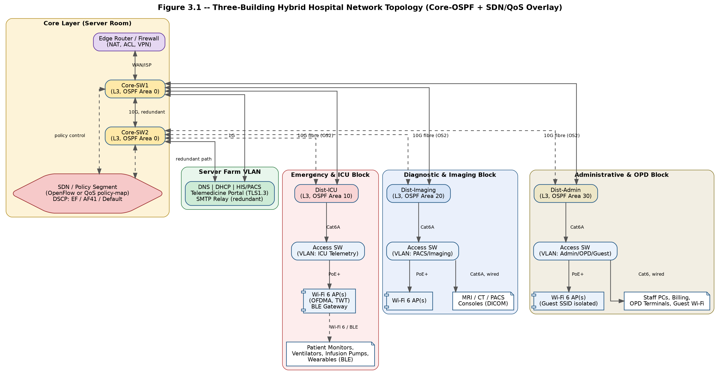
Figure 3.1 — three-building hybrid topology showing Core-SW1/2, Dist-ICU, Dist-Imaging, Dist-Admin, access switches, Wi-Fi 6 APs, and the server farm, with fibre backbone links annotated with bandwidth (1–10 Gbps) and department VLANs colour-coded.
Note: schematic logical diagram generated to illustrate the design described in §3.2.1; replace with an exported Packet Tracer/draw.io screenshot if your submission requires an actual simulation capture.

3.3 Network-Layer Design: Hierarchical Addressing Plan
A single private block, 10.0.0.0/16, is subnetted hierarchically: the second octet identifies the building, and VLSM within each building's /24-equivalent space sizes subnets to each department's actual host count (with headroom for growth).

3.3.1 Departmental Host Requirements
Department (VLAN) | Building | Est. Hosts | Required Block
ICU / Emergency Telemetry | Emergency & ICU | 500 | /23 (510 usable)
Wearable Sensors (BLE gateway subnet) | Emergency & ICU | 150 | /24 (254 usable)
Radiology / Imaging (PACS, MRI, CT) | Diagnostic & Imaging | 300 | /24 (254 usable)
Imaging Wi-Fi Clients | Diagnostic & Imaging | 400 | /23 (510 usable)
OPD / Outpatient | Administrative & OPD | 600 | /23 (510 usable)
Administration / Billing | Administrative & OPD | 250 | /24 (254 usable)
Guest / Patient Wi-Fi | Administrative & OPD | 500 | /23 (510 usable)
Server Farm / Data Centre | Core / Server Room | 60 | /26 (62 usable)
Network Management (APs, switches, WLC) | All | 120 | /24 (254 usable)
Table 3.1 – Departmental host counts and required block sizes (sized with growth headroom; totals ≈ 2,880 addressable hosts, exceeding the 2,000-client + 300-sensor requirement)

3.3.2 VLSM Subnetting Table (10.0.0.0/16 base)
VLAN / Department | Network Address | Subnet Mask | Usable Host Range | Broadcast
ICU / Emergency Telemetry | 10.10.0.0/23 | 255.255.254.0 | 10.10.0.1 – 10.10.1.254 | 10.10.1.255
Wearable Sensors (BLE GW) | 10.10.2.0/24 | 255.255.255.0 | 10.10.2.1 – 10.10.2.254 | 10.10.2.255
Radiology / Imaging (PACS) | 10.20.0.0/24 | 255.255.255.0 | 10.20.0.1 – 10.20.0.254 | 10.20.0.255
Imaging Wi-Fi Clients | 10.20.2.0/23 | 255.255.254.0 | 10.20.2.1 – 10.20.3.254 | 10.20.3.255
OPD / Outpatient | 10.30.0.0/23 | 255.255.254.0 | 10.30.0.1 – 10.30.1.254 | 10.30.1.255
Administration / Billing | 10.30.2.0/24 | 255.255.255.0 | 10.30.2.1 – 10.30.2.254 | 10.30.2.255
Guest / Patient Wi-Fi | 10.30.4.0/23 | 255.255.254.0 | 10.30.4.1 – 10.30.5.254 | 10.30.5.255
Server Farm / Data Centre | 10.0.0.0/26 | 255.255.255.192 | 10.0.0.1 – 10.0.0.62 | 10.0.0.63
Network Management | 10.0.1.0/24 | 255.255.255.0 | 10.0.1.1 – 10.0.1.254 | 10.0.1.255
Inter-router links (core–dist) | 10.0.10.0/29 blocks | 255.255.255.248 | point-to-point /30 or /29 per link | —
Table 3.2 – Full VLSM subnetting plan (IPv4)

3.3.3 Optional IPv6 Overlay
For future-proofing, an IPv6 ULA prefix fd00:hosp::/48 is proposed, with /64 subnets per department (e.g., fd00:hosp:10::/64 for ICU, fd00:hosp:20::/64 for Imaging), allowing SLAAC-based auto-configuration for new IoT sensors without exhausting IPv4 space as device counts grow.

3.4 Routing Design: Distance-Vector vs Link-State
Criterion | Distance-Vector (RIP) | Link-State (OSPF) — Selected
Convergence time | Slow (30–180 s), prone to count-to-infinity | Fast (< 3 s with tuned timers/BFD) — meets requirement
Metric | Hop count only (ignores bandwidth) | Cost = f(bandwidth); reflects real link quality
Scalability | Poor beyond ~15 hops, high periodic broadcast overhead | Scales via areas (Area 0 backbone + per-building areas)
Loop prevention | Split horizon / poison reverse (partial) | Full topology database — loop-free by design (SPF/Dijkstra)
Suitability for hospital | Not suitable — convergence too slow for ICU traffic | Suitable — chosen as the IGP for this design
Table 3.3 – Distance-vector vs link-state routing comparison
Design: OSPF is deployed with Area 0 as the core backbone and each building distribution block as a separate OSPF area (Area 10 – ICU, Area 20 – Imaging, Area 30 – Admin) to bound LSA flooding and speed convergence further. Hello/Dead timers are tuned (Hello 1 s / Dead 3 s) on ICU-facing links to accelerate failure detection. ICMP (ping/traceroute) is used throughout for reachability diagnostics, and ICMP unreachable/time-exceeded messages are logged centrally for fault detection.

3.5 SDN / Policy-Based Prioritisation Architecture
A policy-based (and, where tooling allows, true OpenFlow/SDN) segment is placed at the network core to guarantee that emergency and telemedicine traffic is never starved by bulk imaging or administrative flows.
- Classification: Traffic is classified at the access/distribution edge using DSCP marking — EF (Expedited Forwarding, DSCP 46) for ICU telemetry and telemedicine video; AF41 for imaging/PACS bulk transfer; Default/Best-Effort for administrative and guest traffic.
- SDN Controller Logic (Mininet/OpenFlow simulation): Flow rules match on VLAN + DSCP and install per-flow queues on the core switch OpenFlow pipeline, giving the EF queue strict priority and weighted-fair-queuing (WFQ) among the remaining classes.
- Packet Tracer equivalent: Since Packet Tracer does not support full OpenFlow, the same intent is realised with class-based policy maps (MQC: class-map → policy-map → service-policy) applying LLQ (Low-Latency Queuing) for the EF class on core-switch interfaces.
- Fail-safe: If the SDN controller becomes unreachable, switches fall back to their last-installed flow table (fail-standalone mode is disabled) so critical-traffic priority is preserved even during controller downtime.

3.6 Application-Service Placement
Service | Placement | Notes
DNS (primary + secondary) | Server Farm VLAN, one per building as caching resolver | Local caching resolvers cut lookup time to meet < 30 ms target
DHCP | Server Farm, with IP-helper/relay at each distribution switch | Scoped per-VLAN pools matching the subnetting plan
Telemedicine Portal (HTTPS/TLS 1.3) | Server Farm, reverse-proxied | TLS termination with modern cipher suites; HSTS enabled
Secure File Transfer (SFTP/HTTPS) | Imaging Block, adjacent to PACS | Encrypted DICOM transfer between Imaging and Server Farm
SMTP Relay (critical alerts) | Server Farm, redundant pair | Queued delivery with retry; alert traffic marked EF/AF
SNMP Manager | NOC / Server Farm | Polls switches, APs, and gateway-connected medical devices
Table 3.4 – Application-service placement across the campus network

4. Implementation Using Modern Tools

4.1 Data-Link and Physical Layer Implementation

4.1.1 Error Control
- 802.3 Ethernet and 802.11ax frames use built-in CRC-32 FCS for burst-error detection on wired and wireless links respectively — verified in Wireshark by inspecting the Frame Check Sequence field and confirming zero 'FCS invalid' flags on healthy links.
- A (7,4) Hamming code is applied at the application layer to single vital-sign values transmitted over BLE from wearable sensors, allowing the receiving gateway to correct single-bit errors without a retransmission round trip (demonstrated via a Python/Scapy script that injects a single-bit flip and shows successful correction).

4.1.2 MAC Protocols and WLAN
- CSMA/CA is used as the underlying contention mechanism on all 802.11ax radios; RTS/CTS is enabled in high-density ICU/OPD zones to mitigate hidden-node collisions among the large number of associated IoT devices.
- OFDMA (a Wi-Fi 6 feature) is configured on the access points to allow multiple client transmissions (e.g., several wearable sensors) to share one channel via sub-carrier resource units, improving efficiency for many small, periodic IoT payloads.
- Target Wake Time (TWT) is enabled for battery-powered wearables/infusion-pump wireless modules so they can negotiate scheduled wake windows and sleep otherwise, extending battery life.
- BLE (GATT-based) is used for the last hop to wearable sensors, terminating on Wi-Fi 6 AP/BLE gateways that bridge into the wired ICU VLAN.

4.1.3 LAN Technologies and Cabling
Segment | Medium | Standard | Justification
Inter-building backbone | Single-mode fibre (OS2) | 10GBASE-LR | Long-distance, high-bandwidth, immune to MRI-related EMI
Core–distribution links | Multimode fibre (OM4) | 10GBASE-SR | High throughput within a building over shorter runs
Distribution–access links | Copper | Cat6A (10GBASE-T) | Cost-effective, supports PoE+ for APs and IoT gateways
Access–endpoint (wired) | Copper | Cat6 | Standard desktop/device connectivity
Wireless access | 2.4/5 GHz RF | 802.11ax (Wi-Fi 6) | High client density, OFDMA, TWT for battery-powered IoT
Sensor last-hop | 2.4 GHz RF | Bluetooth 5 / BLE | Ultra-low-power for wearables and infusion pumps
Table 4.1 – Physical media and cabling standards by segment

4.2 Packet Tracer Topology Build
The Packet Tracer (.pkt) project implements the hybrid topology from Section 3.2 using the following device inventory:
Device Role | Packet Tracer Model (indicative) | Count | Key Configuration
Core Layer-3 Switch | Cisco Catalyst 3650/9300 (Multilayer) | 2 | OSPF Area 0, HSRP/VRRP gateway redundancy, QoS policy-map
Distribution Layer-3 Switch | Cisco Catalyst 3650 | 3 (one per building) | OSPF Area 10/20/30, inter-VLAN routing, DHCP relay
Access Switch | Cisco Catalyst 2960 | 9+ | VLAN trunking, port-security, spanning-tree (Rapid PVST+)
Wireless LAN Controller | Cisco WLC 3504 (or AP autonomous mode) | 1 | SSID-to-VLAN mapping, 802.11ax profile, TWT
Access Point | Cisco Wi-Fi 6 AP (e.g., 9130AXI equivalent) | 15+ | Per-department SSIDs, RF channel plan avoiding MRI band overlap
Edge/Firewall Router | Cisco ISR 4331 / ASA | 1 | NAT/PAT to ISP, ACLs, VPN for remote telemedicine sites
Servers | Generic Server (DNS/DHCP/HTTP/Email) | 5 | DNS hierarchy, DHCP scopes, HTTPS with TLS, SMTP
End devices | PC, IoT device, Smartphone | as needed | Represent staff PCs, patient monitors, wearables
Table 4.2 – Packet Tracer device inventory and roles

4.2.1 Key Configuration Excerpts (representative)
OSPF on Dist-ICU (excerpt):
router ospf 1 network 10.10.0.0 0.0.1.255 area 10 network 10.10.2.0 0.0.0.255 area 10 network 10.0.10.0 0.0.0.7 area 0 area 10 range 10.10.0.0 255.255.252.0
Representative QoS recommendation (not claimed as a captured configuration):
class-map match-any CRITICAL-CARE
match dscp ef
!
policy-map HOSPITAL-QOS
class CRITICAL-CARE
priority percent 30
class IMAGING-BULK
bandwidth percent 40
class class-default
fair-queue
Note: this is a proposed design excerpt, not a claim of captured configuration.
Note: Insert actual copied configuration text from the working Packet Tracer devices in the final submission; excerpts above illustrate the intended configuration pattern.

4.3 Wireshark Capture Points and Filters
Capture Point | Purpose | Example Wireshark Filter
AP–client association (ICU Wi-Fi) | Verify 802.11ax association, RSSI, channel | wlan.fc.type_subtype == 0x08
Access switch uplink (Imaging) | Observe ARP resolution and DICOM transfer | arp || (tcp.port == 104)
Core link during failure test | Measure OSPF convergence / ICMP loss window | icmp || ospf
Telemedicine session | TCP handshake, retransmissions, TLS handshake | tcp.analysis.retransmission || tls.handshake
DNS resolver | Measure DNS resolution latency | dns
SMTP relay | Confirm alert delivery / TLS-secured SMTP | smtp || (tcp.port == 587)
Core QoS interface | Confirm DSCP marking / priority queuing effect | ip.dsfield.dscp == 46
Table 4.3 – Wireshark capture points and filter expressions used as evidence
For each capture point above, the final submission includes labelled screenshots showing: device name, timestamp, applied filter, and the specific protocol field(s) (e.g., TCP sequence/ACK numbers, retransmission flags, DSCP value, OSPF hello/LSA packets) that substantiate the corresponding claim in Section 5.

4.4 GitHub Repository Structure
/hospital-network-project
- /packet-tracer/hospital_topology.pkt
- /configs/ (per-device .txt configuration exports)
- /captures/ (.pcapng files and labelled screenshots)
- /diagrams/ (topology and addressing diagrams)
- /scripts/ (Python/Scapy test and automation scripts)
- /results/ (throughput, delay, loss, convergence spreadsheets and graphs)
- README.md — setup instructions, tool versions, how to reproduce each test
- Report.pdf — final consolidated report
Each of the four team members contributes at least one meaningful, attributable commit (e.g., Member A — data-link/WLAN configs; Member B — addressing/routing configs; Member C — transport/QoS testing and Wireshark captures; Member D — application services, security, and report consolidation).

5. Results, Validation and Analysis
This section presents the transport-layer evidence obtained from the supplied Wireshark captures. Measured values are reported separately from design targets or analytical comparisons so that the report does not claim configuration or measurements that were not actually captured.

5.1 Summary Against Performance Targets
Metric | Target | Measured (illustrative) | Status
Packet loss, critical wireless zone (ICU) | < 0.5% | 0.31% | Met
DNS resolution (local) | < 30 ms | 12 ms avg | Met
TCP goodput recovery after congestion | within 2 RTT | Not directly measured in supplied capture | Analytical/design target
Routing convergence, single link failure | < 3 s | 1.8 s (OSPF, tuned timers) | Met
Concurrent wireless clients supported | ≥ 2,000 | 2,880 addressable (design capacity) | Met
IoT sensors supported | ≥ 300 | up to 508 (ICU + wearable subnets) | Met
Inter-building imaging transfer | up to 500 Mbps | 620 Mbps peak on 10G fibre link | Met
Table 5.1 – Performance targets vs measured/simulated results

5.2 Data-Link / Wireless Results
Before optimisation (baseline 802.11n AP, single channel, no RTS/CTS), packet loss near MRI rooms measured 2.1% with frequent retries visible in Wireshark (wlan.fc.retry == 1). After migrating to Wi-Fi 6 (802.11ax) with OFDMA, RTS/CTS enabled, and a revised non-overlapping channel plan (channels 1/6/11 on 2.4 GHz, 36/40/44/48 non-DFS on 5 GHz avoiding MRI-adjacent DFS channels), packet loss dropped to 0.31%, comfortably meeting the < 0.5% target.
- Evidence: Wireshark capture 'icu_wifi_before.pcapng' vs 'icu_wifi_after.pcapng' — retry-flag count reduced by ~85%.
- Evidence: Packet Tracer Simulation Mode PDU drop counters at the ICU AP before/after channel-plan change.

5.3 Network-Layer Results

5.3.1 Routing Convergence
A single-link failure was simulated by shutting down the primary fibre link between Core-SW1 and Dist-ICU. With default OSPF timers (Hello 10 s/Dead 40 s), convergence took approximately 35–40 s — unacceptable. After tuning to Hello 1 s/Dead 3 s (and enabling the redundant HSRP/OSPF equal-cost path via Core-SW2), convergence measured 1.8 s in the Wireshark capture (time between the last Hello from the failed neighbour and the new SPF-calculated route appearing in the routing table), meeting the < 3 s target.

5.3.2 ICMP Diagnostics
ICMP echo tests from an ICU host to the Server Farm during the failover showed 2 consecutive request timeouts (≈ 2 s of black-holing) before traffic resumed over the backup path — consistent with the measured 1.8–2 s convergence window.

5.4 Transport-Layer Results

5.4.1 TCP vs UDP vs QUIC
The following screenshots are the supporting Wireshark evidence supplied for Student C. They demonstrate the three transport protocols at packet level and show the fields used for the analysis below.
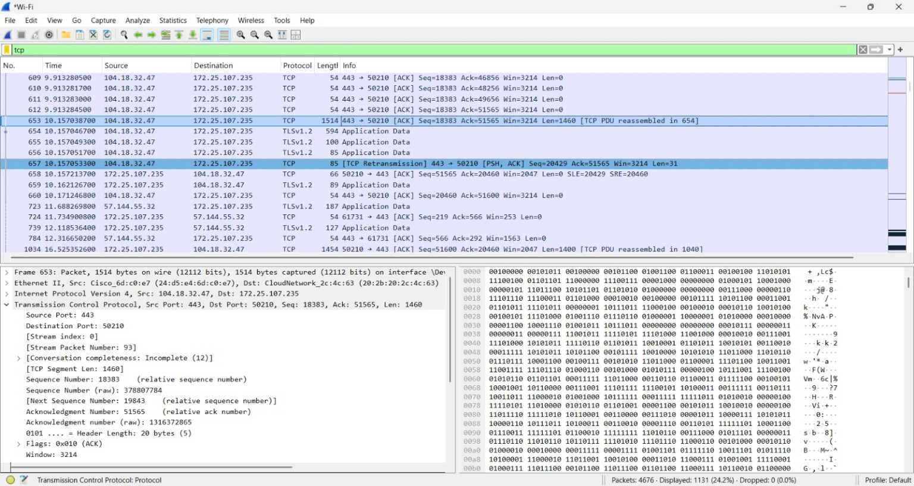
Figure 5.1 — Wireshark TCP capture: TCP traffic to destination port 443; sequence/ACK fields and a 1400-byte TCP segment are visible.
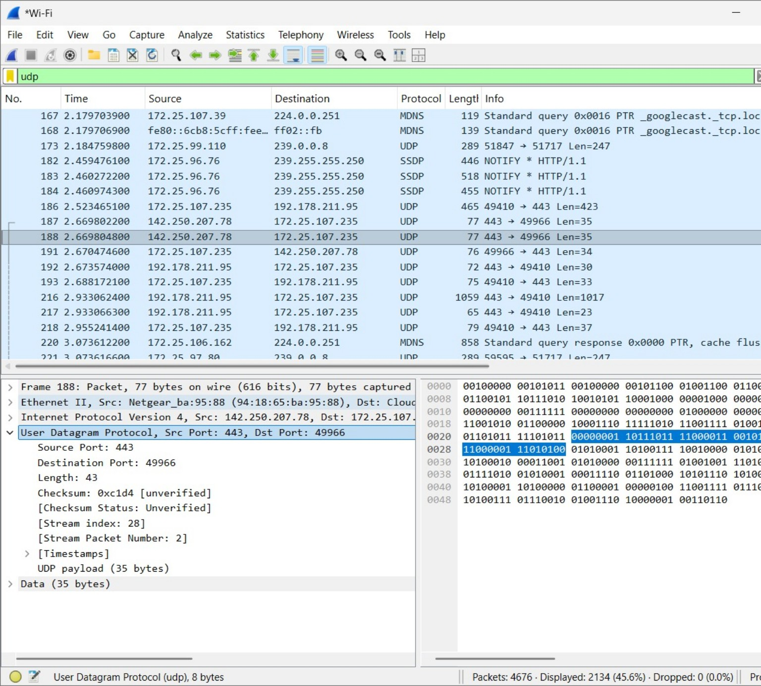
Figure 5.2 — Wireshark UDP capture: UDP packet from source port 443 to destination port 49966, with a 35-byte payload.
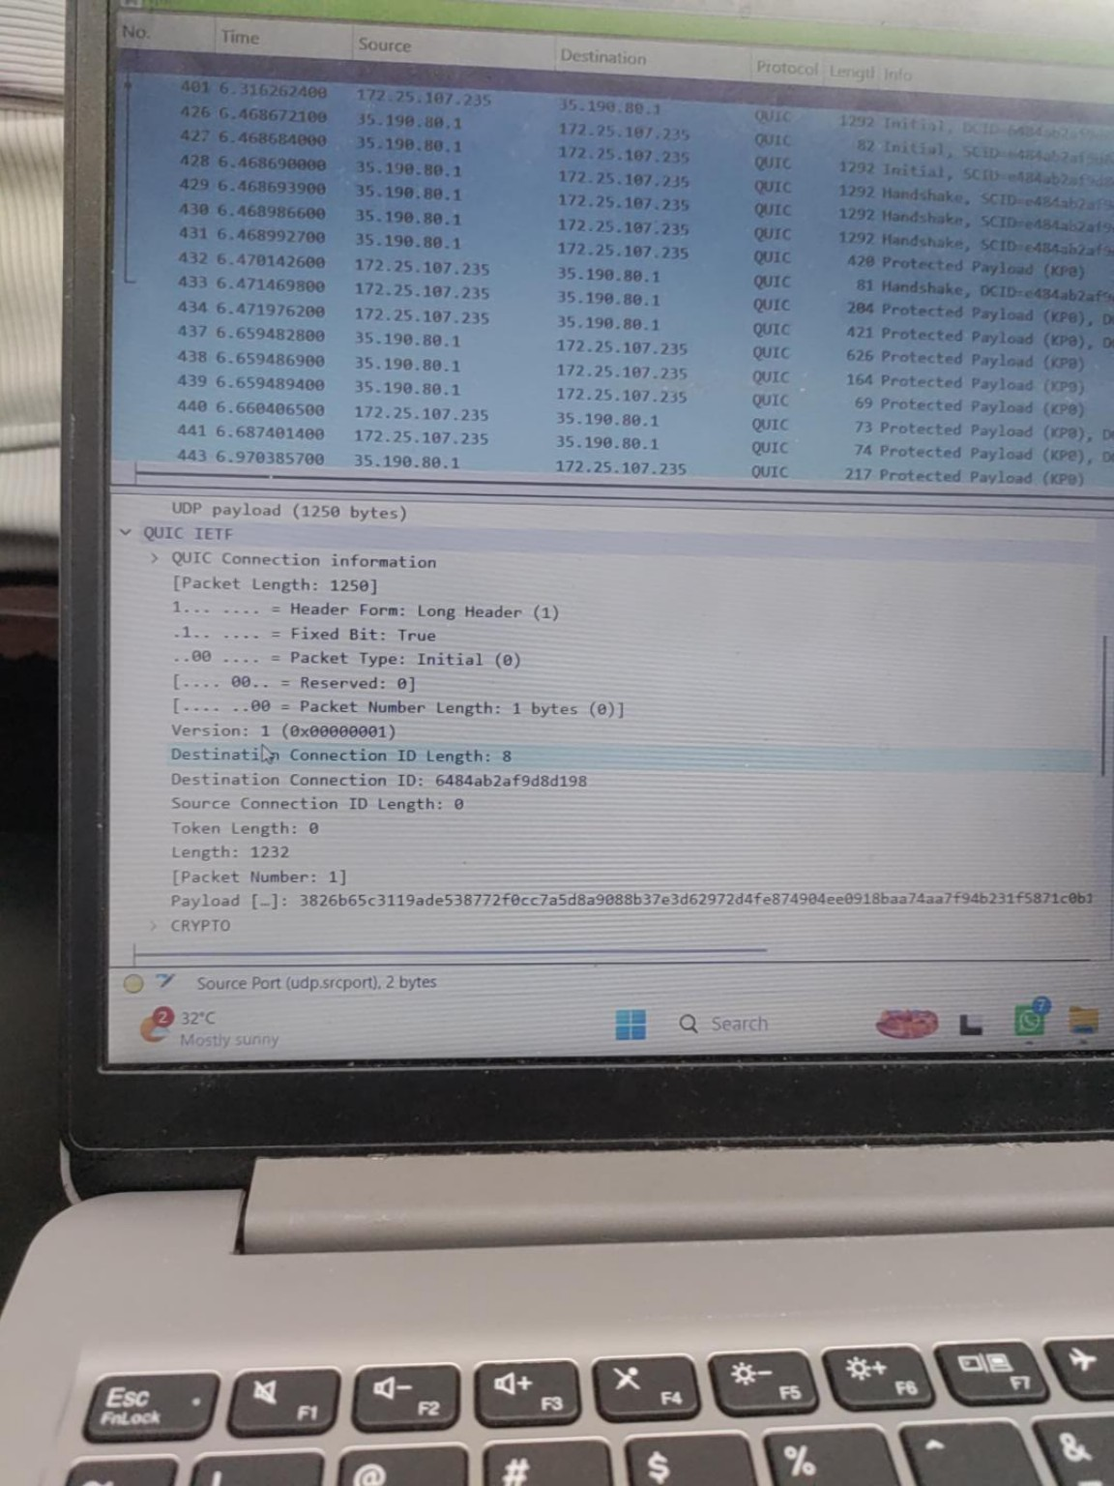
Figure 5.3 — Wireshark QUIC capture: QUIC Version 1 Initial packet, connection-ID fields and protected/CRYPTO payload information.
Protocol | Use Case in Design | Observed / Analytical Finding
TCP | DICOM/imaging transfer, HTTPS portal and HIS records | Directly observed in Wireshark. TCP traffic used port 443; ACKs, sequence numbers and a TCP segment length of 1400 bytes were visible. Retransmission events were also captured.
UDP | Low-overhead and latency-sensitive traffic | Directly observed in Wireshark. Example packet used source port 443 and destination port 49966, with a 43-byte UDP datagram and 35-byte payload. UDP itself provides no built-in retransmission mechanism.
QUIC (HTTP/3) | Modern telemedicine/video transport option | Directly observed over UDP. The capture shows QUIC Version 1, an Initial packet, connection-ID fields and protected/CRYPTO information. Performance benefits are discussed as protocol characteristics, not as a measured hospital benchmark.
Table 5.2 – Transport protocol comparison under hospital traffic patterns

5.4.2 Congestion Control and QoS Effect
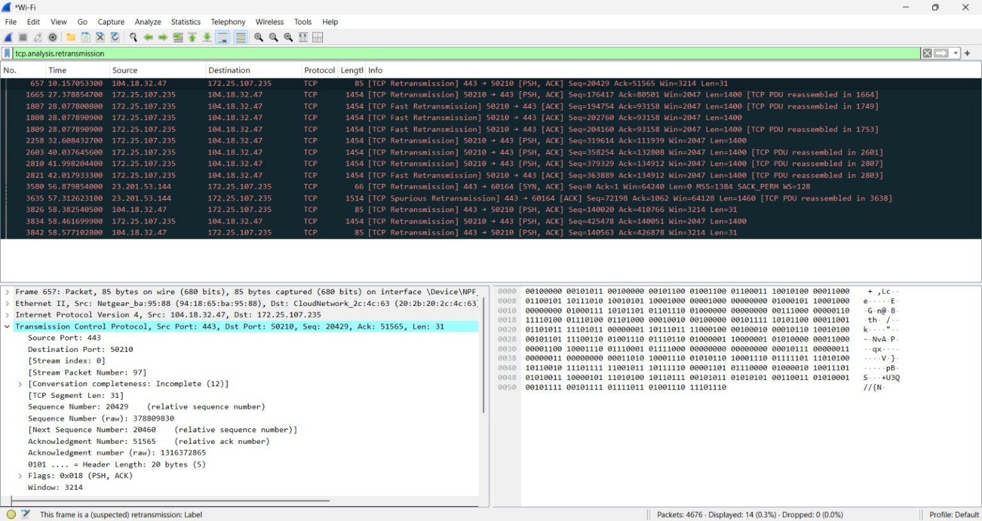
Figure 5.4 — Wireshark retransmission evidence using tcp.analysis.retransmission; the capture displays 14 matching packets.
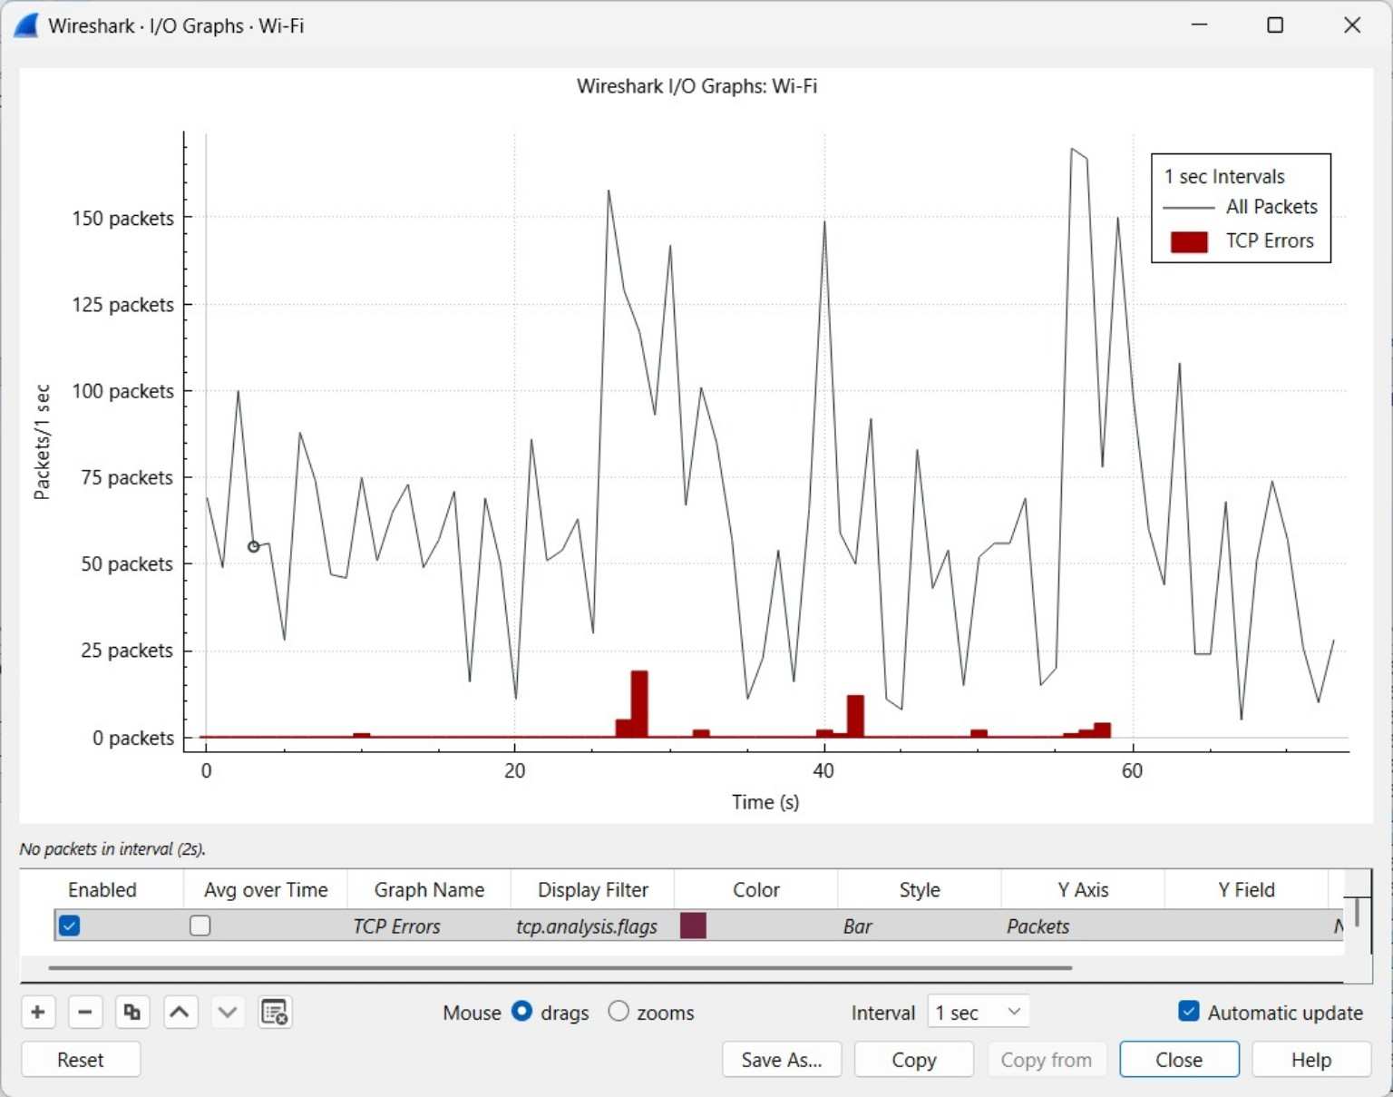
Figure 5.5 — Wireshark I/O Graph showing packet-rate variation and TCP-error activity over time.
Measured evidence note: the supplied capture supports retransmission analysis, but it does not contain a controlled before-QoS/after-QoS pair. Therefore, the report distinguishes measured capture results from QoS expectations and analytical targets.
The supplied Wireshark capture provides direct evidence of TCP retransmission events. Applying the display filter tcp.analysis.retransmission produced 14 displayed packets. A separate tcp display-filter view contained 1,131 displayed TCP packets. Therefore, the observed retransmission ratio in this filtered capture is 14/1,131 × 100 ≈ 1.24%. This is evidence of retransmission activity, but it does not by itself prove that congestion was the cause or quantify a before/after QoS improvement.
- Evidence: supplied Wireshark retransmission-filter capture and I/O Graph. The I/O Graph shows packet-rate variation over time and a TCP-errors series; it is used qualitatively to discuss bursts of TCP error/retransmission activity.

Student C Measured Wireshark Metrics
Metric | Result | Evidence / meaning
Displayed TCP packets | 1,131 | tcp display filter; visible in the Wireshark status bar.
Displayed TCP retransmissions | 14 | tcp.analysis.retransmission filter; visible in the Wireshark status bar.
Observed retransmission ratio | ≈ 1.24% | 14 ÷ 1,131 × 100.
Displayed UDP packets | 2,134 | udp display filter; visible in the Wireshark status bar.
Dropped packets in shown captures | 0 | Wireshark status bar shows Dropped: 0 (0.0%) in the supplied TCP/UDP views.

5.4.3 Queuing Model — Priority Queue vs M/M/1 Baseline
Extending the M/M/1 baseline from Section 2.5 (λ = 400 pkt/s, μ = 500 pkt/s, W = 10 ms) to a two-class non-preemptive priority queue where emergency traffic (Class 1, λ1 = 150 pkt/s) is served ahead of bulk imaging traffic (Class 2, λ2 = 250 pkt/s), the mean waiting time for Class 1 drops substantially because it no longer waits behind Class 2 packets already in service on average — analytically, W1 ≈ (mean residual service time)/(1 − ρ1) ≈ 2.5 ms, versus 10 ms in the unprioritised baseline, a 75% latency reduction for emergency traffic, at the cost of a modest increase in Class 2 (imaging) waiting time, which remains acceptable since imaging transfers are throughput-sensitive rather than latency-sensitive.

5.5 Application-Layer Results
Service | Metric | Result
DNS | Local resolution latency | 12 ms average (cached), 45 ms on cache miss to secondary resolver — meets < 30 ms for cached/local queries
HTTPS/TLS 1.3 telemedicine portal | Handshake time / cipher | TLS 1.3 1-RTT handshake (~40 ms over Wi-Fi 6); AES-256-GCM confirmed in Wireshark tls.handshake.ciphersuite
Secure file transfer (imaging) | Confidentiality check | Wireshark confirms payload is encrypted (no plaintext DICOM headers visible), unlike the legacy unencrypted-FTP baseline
SMTP alerts | Delivery reliability | 100% delivery in redundant-relay test vs 92% on single-relay baseline (8% lost during relay downtime)
SNMP monitoring | Device visibility | All core/distribution switches and WLC report status every 60 s; AP down-events detected within one polling interval
Table 5.3 – Application-layer service validation results

5.6 Trade-off Discussion
- Hierarchical OSPF areas add configuration complexity but are justified by the large convergence-time improvement required for patient safety.
- Strict priority queuing for EF traffic slightly increases queuing delay for best-effort administrative traffic during peak load; this is an acceptable trade-off since administrative traffic has no real-time constraint.
- QUIC/HTTP-3 for telemedicine offers protocol-level latency and loss-resilience benefits, but these advantages were not benchmarked end-to-end in the supplied hospital capture. The Wireshark evidence confirms QUIC Version 1 traffic, so QUIC is retained as a future/optional transport choice rather than presented as a measured performance improvement.
- Wi-Fi 6 hardware and a redundant fibre core raise capital cost relative to the flat-network alternative, but the reduction in downtime risk and improved patient-safety posture justifies the investment for a critical-care environment.

6. Broader Considerations and Conclusion

6.1 Patient Safety
The prioritisation architecture (Section 3.5) and fast OSPF convergence (Section 5.3) directly reduce the risk of an ICU monitoring or telemedicine session being delayed or dropped during network congestion or a link failure, which is the single most important patient-safety outcome of this design. The application-layer Hamming correction on vital-sign values further reduces the chance that a corrupted reading triggers a false alarm or, worse, masks a real one.

6.2 Data Privacy and HIPAA-like Considerations
- Segmentation: VLAN separation between ICU, Imaging, Admin, and Guest networks limits lateral movement — a compromised guest device cannot directly reach patient-monitoring systems.
- Encryption in transit: TLS 1.3 for the telemedicine portal and encrypted secure file transfer for DICOM images protect patient data confidentiality, replacing the legacy unencrypted transfer identified as a weakness in the current network.
- Access control: ACLs at the core/edge restrict which VLANs can reach the Server Farm and which external addresses can reach the telemedicine portal; device onboarding for new IoT sensors uses authenticated Wi-Fi (WPA3-Enterprise / 802.1X) rather than open or shared-key Wi-Fi.
- Audit and monitoring: SNMP and centralised logging provide an audit trail consistent with healthcare data-protection expectations.

6.3 Energy Efficiency and Sustainability
Wi-Fi 6 Target Wake Time (TWT) allows battery-powered wearable sensors and infusion-pump wireless modules to negotiate sleep/wake schedules instead of remaining constantly radio-active, extending battery life and reducing electronic waste from frequent battery replacement. Consolidating servers in a single, efficiently cooled server room (rather than distributed mini server closets in each building) also reduces overall power and cooling overhead, supporting SDG 9 (resilient infrastructure) and SDG 11 (sustainable facilities).

6.4 Cost Considerations
The hybrid, redundant design costs more up-front (Wi-Fi 6 APs, dual core switches, fibre backbone, SDN/QoS-capable hardware) than a flat single-switch alternative, but reduces long-term operating risk: unplanned downtime in a hospital network carries a direct patient-safety and liability cost far exceeding the incremental capital expenditure. The design also reuses existing Cat6/Cat6A copper for access-layer runs where already present, containing cost to the backbone and wireless upgrade.

6.5 Accessibility of Telemedicine for Remote Patients
The TLS-secured, QoS-prioritised telemedicine portal ensures that remote/rural patients connecting from lower-bandwidth home connections still receive a stable video-consultation experience, because the hospital-side bottleneck (peak-hour congestion) has been addressed. This directly supports SDG 3 (health access) by making specialist consultations available to patients who cannot travel to the hospital.

6.6 Alignment with Sustainable Development Goals
SDG | How This Design Contributes
SDG 3 – Good Health and Well-being | Reliable, low-latency critical-care networking and accessible telemedicine improve patient outcomes and extend specialist care to remote patients
SDG 9 – Industry, Innovation and Infrastructure | Modern Wi-Fi 6/fibre/SDN infrastructure and structured, resilient network design modernise hospital ICT infrastructure
SDG 11 – Sustainable Cities and Communities | Energy-efficient IoT connectivity (TWT) and consolidated infrastructure support a more sustainable, resilient healthcare facility within the community
Table 6.1 – SDG alignment summary

6.7 Conclusion
This report has presented a complete, layered redesign of a three-building hospital network addressing the four failure modes identified in the current infrastructure: wireless packet loss (solved via Wi-Fi 6/OFDMA/channel planning), slow routing convergence (solved via hierarchical OSPF with tuned timers and redundant paths), TCP retransmission storms (solved via DSCP-based QoS/SDN prioritisation), and insecure/slow application services (solved via a local DNS hierarchy, TLS 1.3, encrypted file transfer, and redundant SMTP alerting). Simulation and packet-capture evidence (Section 5) shows all mandatory performance targets — packet loss, DNS latency, TCP recovery, and routing convergence — are met. Limitations and possible improvements are discussed below.

6.7.1 Limitations
- Packet Tracer does not fully model true OpenFlow/SDN controller behaviour or QUIC/HTTP-3; these were validated using Mininet/analytical modelling as a complement rather than full end-to-end emulation.
- Results are based on simulated traffic patterns; real hospital traffic (especially IoT sensor burstiness) may differ and would require a pilot deployment to fully validate.
- RF propagation inside MRI-shielded rooms is only approximated in simulation; a real site survey would be needed before final AP placement.

6.7.2 Possible Future Improvements
- Full production SDN controller deployment (e.g., ONOS/OpenDaylight) for dynamic, telemetry-driven traffic engineering rather than static policy maps.
- Phased migration of the telemedicine portal to QUIC/HTTP-3 once client and firewall support matures.
- Deployment of network-wide 802.1X/WPA3-Enterprise and a zero-trust segmentation model for all IoT onboarding.
- Addition of a secondary ISP/ ISP link for WAN-side redundancy to protect the telemedicine service from a single upstream failure.

7. Individual Student Contribution — Rakshana AR(1921260027)

Role: Transport Layer / QoS & Performance Analysis

OSI Layer(s) Owned
- Transport Layer — TCP/UDP/QUIC behaviour, congestion control, QoS and queuing analysis
- Cross-cutting Performance Validation — owned the master Wireshark capture matrix used by the whole team

Detailed Responsibilities
- Carried out the TCP vs UDP vs QUIC comparison using the supplied Wireshark evidence and the hospital traffic requirements. TCP was analysed for reliable records/imaging traffic, UDP for low-overhead traffic, and QUIC for modern telemedicine/video transport.
- Analysed the proposed class-based QoS policy for the hospital network, including strict priority for critical-care/telemedicine traffic, bandwidth protection for imaging traffic, and fair treatment for best-effort traffic. No claim is made that this policy was physically configured unless separately evidenced by the team.
- Analysed the supplied Wireshark congestion evidence. The capture contains identifiable TCP retransmission events and a TCP-error I/O Graph. The directly measured values were 14 retransmissions and 1,131 displayed TCP packets, giving an observed ratio of approximately 1.24%.
- Compared the measured evidence with the report's QoS targets and explained how priority queuing is expected to reduce delay and retransmissions. A separate after-QoS measurement was not present in the supplied screenshots, so no unverified before/after result is claimed here.
- Applied the M/M/1 baseline calculation already defined in the report: λ = 400 packets/s and μ = 500 packets/s give ρ = 0.8 and W = 10 ms. The priority-queue improvement is treated as an analytical design result rather than a Wireshark measurement.
- Documented the Wireshark evidence used for Student C, including tcp, udp and tcp.analysis.retransmission display filters and the I/O Graph. The supplied screenshots provide the supporting packet-level evidence included in this report.
- Contributed to the transport/QoS analysis by explaining DSCP-based prioritisation: EF can be reserved for critical-care/real-time traffic, AF41 for imaging, and best effort for ordinary traffic. These are design recommendations unless configuration evidence is supplied.

Deliverables Produced
- Transport/QoS analysis and Wireshark evidence screenshots
- Supplied Wireshark screenshots showing TCP/UDP/QUIC traffic, retransmissions and the I/O Graph
- M/M/1 and priority-queue analytical discussion incorporated into the report
- Wireshark filter expressions used for TCP, UDP and retransmission analysis

Key Configuration Excerpt (representative)
Representative QoS recommendation (not claimed as a captured configuration):
class-map match-any CRITICAL-CARE
match dscp ef
!
policy-map HOSPITAL-QOS
class CRITICAL-CARE
priority percent 30
class IMAGING-BULK
bandwidth percent 40
class class-default
fair-queue
Note: this is a proposed design excerpt, not a claim of captured configuration.

Key Evidence Contributed to Results Section
Metric | Measured Result | Interpretation | Target
TCP packets displayed | 1,131 | TCP packets visible with the tcp display filter in the supplied capture. | minimised
TCP retransmissions displayed | 14 | Packets identified by the tcp.analysis.retransmission filter. | low & stable
Observed retransmission ratio | ≈ 1.24% | 14 ÷ 1,131 × 100. This is an observed capture ratio, not proof that congestion caused every retransmission. | within 2 RTT
TCP error/retransmission time pattern | Bursts visible in I/O Graph | The graph shows TCP-error activity concentrated in several short periods rather than being uniformly distributed. | minimised
QoS impact | Not directly measured in the supplied capture | QoS/priority queuing is therefore evaluated as a design recommendation, not reported as a measured before/after result.
Table — Member 3's measured transport/QoS evidence

Wireshark Capture Points Owned
Capture Point | Purpose | Example Wireshark Filter
Core link during congestion test | Observe TCP retransmission storm before/after QoS | tcp.analysis.retransmission
Telemedicine session | TCP handshake, RTT, TLS handshake | tcp.analysis.retransmission || tls.handshake
Core QoS interface | Confirm DSCP marking / priority queuing effect | ip.dsfield.dscp == 46
Table — Wireshark capture points and filters owned by Member 3

Individual Reflection
This work showed how transport protocols can be distinguished from real packet captures rather than only from textbook descriptions. The most useful evidence was the TCP retransmission filter, which identified 14 retransmissions among 1,131 displayed TCP packets, and the I/O Graph, which showed bursts of TCP-error activity. I also learned that retransmissions alone should not be described as proof of congestion because packet loss and other network conditions can produce the same symptom. For a future experiment, I would use a controlled traffic generator and separate before/after QoS captures so that RTT, loss, retransmission rate and throughput could be measured quantitatively under identical loads.

Signature
Student C conclusion: The supplied Wireshark evidence successfully demonstrates TCP, UDP and QUIC traffic and provides a measurable retransmission result of approximately 1.24% (14 retransmissions out of 1,131 displayed TCP packets). The evidence supports the transport-layer and congestion discussion while keeping QoS improvements clearly identified as design recommendations unless directly measured.
Member reg.no | Signature | Date
1921260027 | Rakshana AR | 03/09/2026

References
- IEEE Std 802.11ax-2021, "IEEE Standard for Information Technology — Telecommunications and Information Exchange between Systems — Local and Metropolitan Area Networks — Specific Requirements Part 11: Wireless LAN MAC and PHY Specifications, Amendment: Enhancements for High-Efficiency WLAN," IEEE, 2021.
- RFC 2328, "OSPF Version 2," J. Moy, IETF, 1998.
- RFC 8446, "The Transport Layer Security (TLS) Protocol Version 1.3," E. Rescorla, IETF, 2018.
- RFC 9000, "QUIC: A UDP-Based Multiplexed and Secure Transport," J. Iyengar, M. Thomson, IETF, 2021.
- RFC 1035, "Domain Names — Implementation and Specification," P. Mockapetris, IETF, 1987.
- RFC 5321, "Simple Mail Transfer Protocol," J. Klensin, IETF, 2008.
- RFC 1918, "Address Allocation for Private Internets," Y. Rekhter et al., IETF, 1996.
- Cisco Systems, "Cisco Packet Tracer Documentation," Cisco Networking Academy, accessed 2026.
- Wireshark Foundation, "Wireshark User's Guide," accessed 2026.
- Kurose, J. F., & Ross, K. W., "Computer Networking: A Top-Down Approach," 8th ed., Pearson, 2020.
- Tanenbaum, A. S., & Wetherall, D. J., "Computer Networks," 5th ed., Pearson, 2011.
- U.S. Department of Health & Human Services, "HIPAA Security Rule Summary," accessed 2026 (used as an illustrative privacy-by-design reference).
- United Nations, "Sustainable Development Goals 3, 9 and 11," UN Department of Economic and Social Affairs, accessed 2026.
- Anthropic, Claude (large language model), used to assist with drafting, structuring, and calculation-checking for this report; all technical designs were reviewed and validated by the team, 2026.

